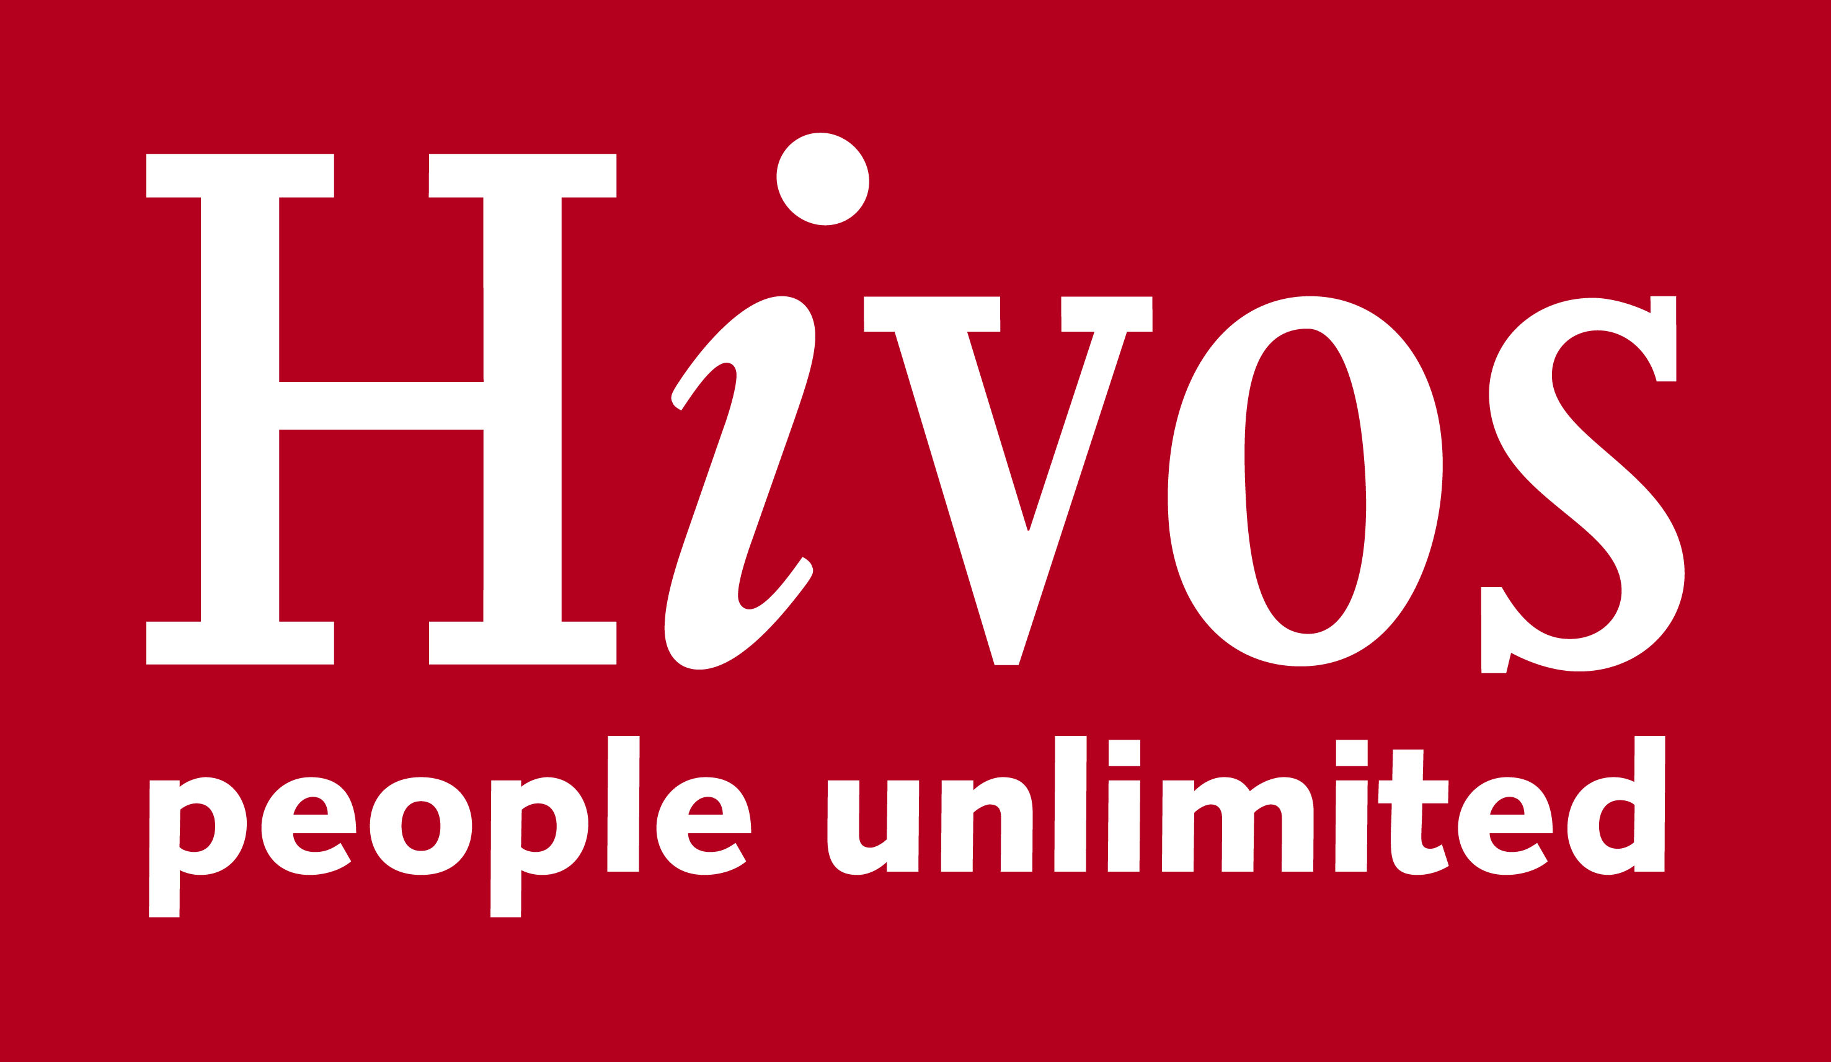
SUPPLIER PREQUALIFICATION DOCUMENT
- INTRODUCTION TO HIVOS FOUNDATION
Hivos is an international development organization guided by humanist values. Together with citizens and their organizations, we aim to contribute towards just, inclusive and life-sustaining societies where people have equal access to opportunities, rights and resources. We work in partnership with others in the Middle East, Africa, Asia and Latin America on three impact areas: civic rights; gender equality, diversity and inclusion, and climate justice. Our approach is solution driven, and we build wider movements for change by amplifying and connecting voices.

To meet this objective, Hivos continuously seeks to partner with competent suppliers and service providers for supply of various goods and provision of various services.

Please read through this document carefully and provide requested information together with all supporting documents.

- IMPORTANT NOTES TO SUPPLIERS

- The purpose of this document is to assist Hivos East Africa in the identification and evaluation of potential suppliers who may subsequently be invited to tender.
- In order to simplify this process, you need to provide scanned certified copies of all supporting documents requested under the questionnaire. You may also be asked to clarify your answers or provide more details. Please answer every question. If the question does not apply to you please write N/A; if you don’t know the answer please write N/K
- Failure to complete this questionnaire and/or provide written answers to any further questions or requests for additional information or request for clarifications will result in the supplier’s elimination from further consideration.
- Please note that by responding to this questionnaire you accept that all answers provided in this questionnaire are legally binding on the supplier and should any need arise, may be used as evidence in any court of law which has jurisdiction. Further, Hivos East Africa reserves the right without further recourse to verify at its own cost the accuracy of any answers provided herein.
- Where necessary and if sufficient space has not been provided on the questionnaire for the answers, please provide the answers as supplements on separate sheets
- Please put initials and rubber stamp each page and sign the last page in the space provided
- Please return the completed questionnaire* via email to procurement-ea@hivos.org on or before the date shown on the cover page and advertised

*Please note: Hivos Payments are due 30 (thirty) days after receipt of invoice

If you have any queries about this form please contact The Secretary, The Procurement Prequalification Committee, Hivos Foundation via email on procurement-ea@hivos.org

Suppliers willing to be considered for registration as Hivos East Africa suppliers are expected to furnish Hivos East Africa with among others the following vital information, which will be treated in strict confidence. However based on business status some questions may not be relevant.

- COMPANY INFORMATION

NO | PARTICULARS | RESPONSE
3.1 | Full Name of organization:
 |  | Question | Response
 | Is your organization (please answer Yes or No) | i) A public limited company? If yes, please attach copies of the company’s memorandum of association and articles including any change of name
 |  | ii) Publicly listed company? If yes, attach copies as (i)
 |  | Iii) A limited company? If yes, attach copies as i) above
 |  | IV) A partnership? If yes, attach partnership deed
 |  | V) A sole proprietorship? If yes, attach business certificate
 |  | vi)Other (please specify)
3.2 | Date of Registration of your company(attach a copy of certificate of incorporation)
3.3 | Full physical address of principal place of business:
 | Full postal address of the principal place of business (include the postal code)
3.4

3.5 | Office telephone number (s)  Landline:  Mobile:
3.7 | E-mail address
3.8 | Website address (if any):
3.9 | Company PIN-please provide copy
3.10 | VAT Registration number: Please provide copy of certificate
3.11 | Tax compliance- Please provide copy of current tax compliance certificate
3.12 | Proof of registration with relevant government ministry (if applicable to this qualification)
3.13 | Period in which you have been in business
3.21 | Contact person within the organization to whom enquiries about his prequalification should be directed | Name:  Title:  Telephone:  Email:

4. FINANCIAL INFORMATION
No. | PARTICULARS
4.1 | What was your turnover in the last two years | ………………..  For the year ended  ……../………./………. |  | ………………..  For the year ended  ……../………./……….
4.2 | Has your organization met its obligations to pay its creditors and staff during the past year? | Yes/No
 | If no, please give details
4.3 | What is the name and branch of your bankers (who could provide a reference)? | Name of bank
 |  | Branch
 |  | Telephone number
 |  | Postal Address
 |  | Contact person:-
 |  | Name:
 |  | Position:
 |  | Email:
4.4 | Provide copy of the following:
 | A copy of your most recent audited accounts

5. BUSINESS ACTIVITIES
No. | PARTICULARS
5.1 | What are the main business activities of your organization? (Please specify)
5.3 | Please generally describe the experience and expertise your organization possesses that will enable you to effectively and efficiently undertake the work you wish to be prequalified for as required by HIVOS, EA
5.4

6. WORK RELATED REFERENCES
Please provide in the table below details of least 5 previous/current top contracts you have undertaken over the last five years, or that are relevant to this pre-qualification document. Attach copies of LPOs, Letters of award/signed contracts. Note that the referees may be contacted without further reference to you.
No | Customer Organization (name) | Customer Contact name and phone number | Contract reference and brief description | Date contract awarded | Date contract completed | Value of contract (KES.)
6.1
6.2
6.3
6.4
6.5

6.11 | Have you had any contracts terminated for poor performance in the last five years, or any contracts where damages have been claimed by the contracting authority/client? | Yes/No
 | If yes, please give details

7. MANAGEMENT POLICIES
A). Employee Integrity
How does the firm ensure the integrity of staff? Detail any related policies
………………………………………………………………………………………………………………………………………………………………………………………………………………………………………………………………………………………………………………………………………………………………………………………………………………………………………………………………………………………………………………………………………………………………………………………………………………………………………………………………………..
B). Does your company have a code of conduct? If so, please attach a copy.
C). Customer Service
- Does your organization have a documented policy on customer service? If yes, please provide a copy
- Does your firm use any performance management techniques including customer satisfaction measurements? If so, what are the key parameters? Attach sample reports
Note: HIVOS, EA may require that customers for products/services provided by your firm fill out an appraisal form and rate your services for use in a subsequent decisions on whether to shortlist your company.
D). Environmental Policy
Does your organization have a written environmental policy?

8. DECLARATION
I/We declare that to the best of my/our knowledge the answers submitted in this prequalification (and any supporting documentation) are correct. I/we understand that any misrepresentation will render my/our organization ineligible to participate in HIVOS ‘s future tenders
FORM COMPLETED BY
Name:
Position (Job Title)
Date:
Telephone number:
-Office…………….
-Mobile…………..
Email:
Signature:
Stamp/seal
FORM WITNESSED BY:
Name:
Position (Job Title)
Date:
Telephone number:
-Office…………….
-Mobile…………..
Email:
Signature:
Stamp/seal

